第四讲 GridView 72般绝技

作者：清清月儿

主页：http://blog.csdn.net/21aspnet/ 时间：2007.3.24-26

为了写本文，又搭工又搭料，累的2天2宿没睡觉，这篇文章实在是耗费我太多的心血，版权永远属于CSDN社区的清清月儿，请不要试图修改本文，破坏全文的完整性，希望您尊重我的劳动成果！

目录
1.GridView无代码分页排序： 2
2.GridView选中，编辑，取消，删除： 2
3.GridView正反双向排序： 6
4.GridView和下拉菜单DropDownList结合： 8
5.GridView和CheckBox结合： 10
6.鼠标移到GridView某一行时改变该行的背景色方法一： 14
7.鼠标移到GridView某一行时改变该行的背景色方法二： 16
8.GridView实现删除时弹出确认对话框： 17
9.GridView实现自动编号： 17
10.GridView实现自定义时间货币等字符串格式： 19
11.GridView实现用“...”代替超长字符串： 22
12.GridView一般换行与强制换行： 26
13.GridView显示隐藏某一列： 27
14.GridView弹出新页面/弹出制定大小位置新窗口： 32
15.GridView固定表头(不用javascript只用CSS!，很好用)： 34
16.GridView合并表头多重表头无错完美版（以合并3列3行举例） 35
17.GridView突出显示某一单元格（例如金额低于多少，分数不及格等） 40
18.GridView加入自动求和求平均值小计 44
19.GridView数据导入Excel/Excel数据读入GridView 47

1.GridView无代码分页排序：

效果图：
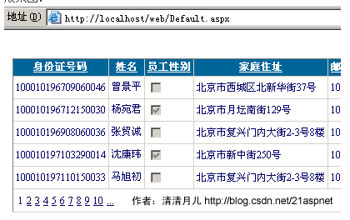
1.AllowSorting设为True，aspx代码中是AllowSorting="True"；
2.默认1页10条，如果要修改每页条数，修改PageSize即可，在aspx代码中是PageSize="12"。
3.默认的是单向排序的，右击GridView弹出“属性”，选择AllowSorting为True即可。

2.GridView选中，编辑，取消，删除：

效果图：
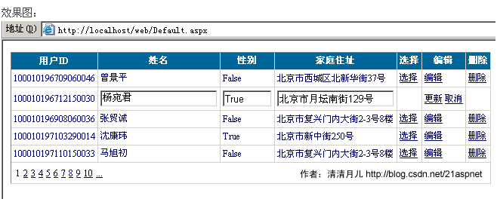

后台代码：
你可以使用sqlhelper,本文没用。代码如下：
using System;
using System.Data;
using System.Configuration;
using System.Web;
using System.Web.Security;
using System.Web.UI;
using System.Web.UI.WebControls;
using System.Web.UI.WebControls.WebParts;
using System.Web.UI.HtmlControls;
using System.Data.SqlClient;

public partial class _Default : System.Web.UI.Page
{

//清清月儿http://blog.csdn.net/21aspnet
SqlConnection sqlcon;
SqlCommand sqlcom;
string strCon = "Data Source=(local);Database=数据库名;Uid=帐号;Pwd=密码";
protected void Page_Load(object sender, EventArgs e)
{
if (!IsPostBack)
{
bind();
}
}
protected void GridView1_RowEditing(object sender, GridViewEditEventArgs e)
{
GridView1.EditIndex = e.NewEditIndex;
bind();
}

//删除
protected void GridView1_RowDeleting(object sender, GridViewDeleteEventArgs e)
{
string sqlstr = "delete from 表 where id='" + GridView1.DataKeys[e.RowIndex].Value.ToString() + "'";
sqlcon = new SqlConnection(strCon);
sqlcom = new SqlCommand(sqlstr,sqlcon);
sqlcon.Open();
sqlcom.ExecuteNonQuery();
sqlcon.Close();
bind();
}

//更新
protected void GridView1_RowUpdating(object sender, GridViewUpdateEventArgs e)
{
sqlcon = new SqlConnection(strCon);
string sqlstr = "update 表 set 字段1='"
+ ((TextBox)(GridView1.Rows[e.RowIndex].Cells[1].Controls[0])).Text.ToString().Trim() + "',字段2='"
+ ((TextBox)(GridView1.Rows[e.RowIndex].Cells[2].Controls[0])).Text.ToString().Trim() + "',字段3='"
+ ((TextBox)(GridView1.Rows[e.RowIndex].Cells[3].Controls[0])).Text.ToString().Trim() + "' where id='"
+ GridView1.DataKeys[e.RowIndex].Value.ToString() + "'";
sqlcom=new SqlCommand(sqlstr,sqlcon);
sqlcon.Open();
sqlcom.ExecuteNonQuery();
sqlcon.Close();
GridView1.EditIndex = -1;
bind();
}

//取消
protected void GridView1_RowCancelingEdit(object sender, GridViewCancelEditEventArgs e)
{
GridView1.EditIndex = -1;
bind();
}

//绑定
public void bind()
{
string sqlstr = "select * from 表";
sqlcon = new SqlConnection(strCon);
SqlDataAdapter myda = new SqlDataAdapter(sqlstr, sqlcon);
DataSet myds = new DataSet();
sqlcon.Open();
myda.Fill(myds, "表");
GridView1.DataSource = myds;
GridView1.DataKeyNames = new string[] { "id" };//主键
GridView1.DataBind();
sqlcon.Close();
}
}

前台主要代码：
... ...
<asp:GridView ID="GridView1" runat="server" AutoGenerateColumns="False" CellPadding="4"
ForeColor="#333333" GridLines="None" OnRowDeleting="GridView1_RowDeleting" OnRowEditing="GridView1_RowEditing"
OnRowUpdating="GridView1_RowUpdating" OnRowCancelingEdit="GridView1_RowCancelingEdit">
<FooterStyle BackColor="#990000" Font-Bold="True" ForeColor="White" />
<Columns>
<asp:BoundField DataField="身份证号码" HeaderText="用户ID" ReadOnly="True" />
<asp:BoundField DataField="姓名" HeaderText="用户姓名" />
<asp:BoundField DataField="员工性别" HeaderText="性别" />
<asp:BoundField DataField="家庭住址" HeaderText="家庭住址" />
<asp:CommandField HeaderText="选择" ShowSelectButton="True" />
<asp:CommandField HeaderText="编辑" ShowEditButton="True" />
<asp:CommandField HeaderText="删除" ShowDeleteButton="True" />
</Columns>
<RowStyle ForeColor="#000066" />
<SelectedRowStyle BackColor="#669999" Font-Bold="True" ForeColor="White" />
<PagerStyle BackColor="White" ForeColor="#000066" HorizontalAlign="Left" />
<HeaderStyle BackColor="#006699" Font-Bold="True" ForeColor="White" />
</asp:GridView>

3.GridView正反双向排序：
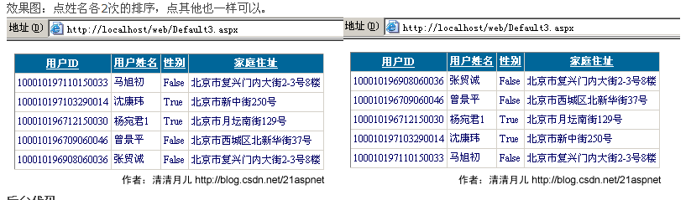后台代码：
using System;
using System.Data;
using System.Configuration;
using System.Collections;
using System.Web;
using System.Web.Security;
using System.Web.UI;
using System.Web.UI.WebControls;
using System.Web.UI.WebControls.WebParts;
using System.Web.UI.HtmlControls;
using System.Data.SqlClient;
public partial class Default3 : System.Web.UI.Page
{

//清清月儿的博客http://blog.csdn.net/21aspnet
SqlConnection sqlcon;
string strCon = "Data Source=(local);Database=北风贸易;Uid=sa;Pwd=";
protected void Page_Load(object sender, EventArgs e)
{
if (!IsPostBack)
{
ViewState["SortOrder"] = "身份证号码";
ViewState["OrderDire"] = "ASC";
bind();
}
}
protected void GridView1_Sorting(object sender, GridViewSortEventArgs e)
{
string sPage = e.SortExpression;
if (ViewState["SortOrder"].ToString() == sPage)
{
if (ViewState["OrderDire"].ToString() == "Desc")
ViewState["OrderDire"] = "ASC";
else
ViewState["OrderDire"] = "Desc";
}
else
{
ViewState["SortOrder"] = e.SortExpression;
}
bind();
}

public void bind()
{

string sqlstr = "select top 5 * from 飞狐工作室";
sqlcon = new SqlConnection(strCon);
SqlDataAdapter myda = new SqlDataAdapter(sqlstr, sqlcon);
DataSet myds = new DataSet();
sqlcon.Open();
myda.Fill(myds, "飞狐工作室");
DataView view = myds.Tables["飞狐工作室"].DefaultView;
string sort = (string)ViewState["SortOrder"] + " " + (string)ViewState["OrderDire"];
view.Sort = sort;
GridView1.DataSource = view;
GridView1.DataBind();
sqlcon.Close();
}
}

前台主要代码：
<asp:GridView ID="GridView1" runat="server" AllowSorting="True" AutoGenerateColumns="False"
CellPadding="3" Font-Size="9pt" OnSorting="GridView1_Sorting" BackColor="White" BorderColor="#CCCCCC" BorderStyle="None" BorderWidth="1px">
<FooterStyle BackColor="White" ForeColor="#000066" />
<Columns>
<asp:BoundField DataField="身份证号码" HeaderText="用户ID" SortExpression="身份证号码" />
<asp:BoundField DataField="姓名" HeaderText="用户姓名" SortExpression="姓名"/>
<asp:BoundField DataField="员工性别" HeaderText="性别" SortExpression="员工性别"/>
<asp:BoundField DataField="家庭住址" HeaderText="家庭住址" SortExpression="家庭住址"/>

</Columns>
<RowStyle ForeColor="#000066" />
<SelectedRowStyle BackColor="#669999" Font-Bold="True" ForeColor="White" />
<PagerStyle BackColor="White" ForeColor="#000066" HorizontalAlign="Left" />
<HeaderStyle BackColor="#006699" Font-Bold="True" ForeColor="White" />
</asp:GridView>

4.GridView和下拉菜单DropDownList结合：

效果图：
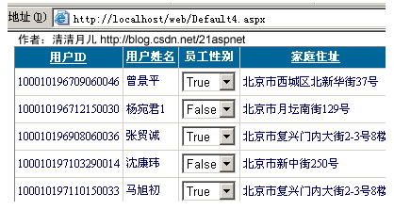

后台代码：
using System;
using System.Data;
using System.Configuration;
using System.Collections;
using System.Web;
using System.Web.Security;
using System.Web.UI;
using System.Web.UI.WebControls;
using System.Web.UI.WebControls.WebParts;
using System.Web.UI.HtmlControls;
using System.Data.SqlClient;
public partial class Default4 : System.Web.UI.Page
{
SqlConnection sqlcon;
string strCon = "Data Source=(local);Database=北风贸易;Uid=sa;Pwd=sa";
protected void Page_Load(object sender, EventArgs e)
{
DropDownList ddl;
if (!IsPostBack)
{
string sqlstr = "select top 5 * from 飞狐工作室";
sqlcon = new SqlConnection(strCon);
SqlDataAdapter myda = new SqlDataAdapter(sqlstr, sqlcon);
DataSet myds = new DataSet();
sqlcon.Open();
myda.Fill(myds, "飞狐工作室");
GridView1.DataSource = myds;
GridView1.DataBind();
for (int i = 0; i <= GridView1.Rows.Count - 1; i++)
{
DataRowView mydrv = myds.Tables["飞狐工作室"].DefaultView[i];
if (Convert.ToString(mydrv["员工性别"]).Trim() == "True")
{
ddl = (DropDownList)GridView1.Rows[i].FindControl("DropDownList1");
ddl.SelectedIndex = 0;
}
if (Convert.ToString(mydrv["员工性别"]).Trim() == "False")
{
ddl = (DropDownList)GridView1.Rows[i].FindControl("DropDownList1");
ddl.SelectedIndex = 1;
}
}
sqlcon.Close();
}
}
public SqlDataReader ddlbind()
{
string sqlstr = "select distinct 员工性别 from 飞狐工作室";
sqlcon = new SqlConnection(strCon);
SqlCommand sqlcom = new SqlCommand(sqlstr, sqlcon);
sqlcon.Open();
return sqlcom.ExecuteReader();
}

前台主要代码：
<asp:GridView ID="GridView1" runat="server" AllowSorting="True" AutoGenerateColumns="False"
CellPadding="3" Font-Size="9pt" BackColor="White" BorderColor="#CCCCCC" BorderStyle="None" BorderWidth="1px">
<FooterStyle BackColor="White" ForeColor="#000066" />
<Columns>
<asp:BoundField DataField="身份证号码" HeaderText="用户ID" SortExpression="身份证号码" />
<asp:BoundField DataField="姓名" HeaderText="用户姓名" SortExpression="姓名"/>
<asp:TemplateField HeaderText="员工性别">
<ItemTemplate>
<asp:DropDownList ID="DropDownList1" runat="server" DataSource='<%# ddlbind()%>' DataValueField="员工性别" DataTextField="员工性别">
</asp:DropDownList>
</ItemTemplate>
</asp:TemplateField>
<asp:BoundField DataField="家庭住址" HeaderText="家庭住址" SortExpression="家庭住址"/>

</Columns>
<RowStyle ForeColor="#000066" />
<SelectedRowStyle BackColor="#669999" Font-Bold="True" ForeColor="White" />
<PagerStyle BackColor="White" ForeColor="#000066" HorizontalAlign="Left" />
<HeaderStyle BackColor="#006699" Font-Bold="True" ForeColor="White" />
</asp:GridView>

5.GridView和CheckBox结合：

效果图：
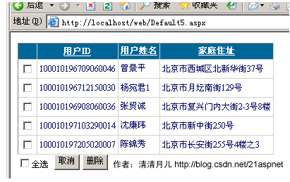

后台代码：

using System;
using System.Data;
using System.Configuration;
using System.Web;
using System.Web.Security;
using System.Web.UI;
using System.Web.UI.WebControls;
using System.Web.UI.WebControls.WebParts;
using System.Web.UI.HtmlControls;
using System.Data.SqlClient;

public partial class Default5 : System.Web.UI.Page
{
//清清月儿http://blog.csdn.net/21aspnet
SqlConnection sqlcon;
string strCon = "Data Source=(local);Database=北风贸易;Uid=sa;Pwd=sa";
protected void Page_Load(object sender, EventArgs e)
{
if (!IsPostBack)
{
bind();
}
}
protected void CheckBox2_CheckedChanged(object sender, EventArgs e)
{
for (int i = 0; i <= GridView1.Rows.Count - 1; i++)
{
CheckBox cbox = (CheckBox)GridView1.Rows[i].FindControl("CheckBox1");
if (CheckBox2.Checked == true)
{
cbox.Checked = true;
}
else
{
cbox.Checked = false;
}
}
}
protected void Button2_Click(object sender, EventArgs e)
{
sqlcon = new SqlConnection(strCon);
SqlCommand sqlcom;
for (int i = 0; i <= GridView1.Rows.Count - 1; i++)
{
CheckBox cbox = (CheckBox)GridView1.Rows[i].FindControl("CheckBox1");
if (cbox.Checked == true)
{

string sqlstr = "delete from 飞狐工作室 where 身份证号码='" + GridView1.DataKeys[i].Value + "'";
sqlcom = new SqlCommand(sqlstr, sqlcon);
sqlcon.Open();
sqlcom.ExecuteNonQuery();
sqlcon.Close();
}
}
bind();
}
protected void Button1_Click(object sender, EventArgs e)
{
CheckBox2.Checked = false;
for (int i = 0; i <= GridView1.Rows.Count - 1; i++)
{
CheckBox cbox = (CheckBox)GridView1.Rows[i].FindControl("CheckBox1");
cbox.Checked = false;
}
}
public void bind()
{
string sqlstr = "select top 5 * from 飞狐工作室";
sqlcon = new SqlConnection(strCon);
SqlDataAdapter myda = new SqlDataAdapter(sqlstr, sqlcon);
DataSet myds = new DataSet();
sqlcon.Open();
myda.Fill(myds, "tb_Member");
GridView1.DataSource = myds;
GridView1.DataKeyNames = new string[] { "身份证号码" };
GridView1.DataBind();
sqlcon.Close();
}
}

前台主要代码：

<asp:GridView ID="GridView1" runat="server" AllowSorting="True" AutoGenerateColumns="False"
CellPadding="3" Font-Size="9pt" BackColor="White" BorderColor="#CCCCCC" BorderStyle="None" BorderWidth="1px">
<FooterStyle BackColor="White" ForeColor="#000066" />
<Columns>
<asp:TemplateField>
<ItemTemplate>
<asp:CheckBox ID="CheckBox1" runat="server" />
</ItemTemplate>
</asp:TemplateField>
<asp:BoundField DataField="身份证号码" HeaderText="用户ID" SortExpression="身份证号码" />
<asp:BoundField DataField="姓名" HeaderText="用户姓名" SortExpression="姓名"/>

<asp:BoundField DataField="家庭住址" HeaderText="家庭住址" SortExpression="家庭住址"/>

</Columns>
<RowStyle ForeColor="#000066" />
<SelectedRowStyle BackColor="#669999" Font-Bold="True" ForeColor="White" />
<PagerStyle BackColor="White" ForeColor="#000066" HorizontalAlign="Left" />
<HeaderStyle BackColor="#006699" Font-Bold="True" ForeColor="White" />
</asp:GridView>
<asp:CheckBox ID="CheckBox2" runat="server" AutoPostBack="True" Font-Size="9pt" OnCheckedChanged="CheckBox2_CheckedChanged"
Text="全选" />
<asp:Button ID="Button1" runat="server" Font-Size="9pt" Text="取消" OnClick="Button1_Click" />
<asp:Button ID="Button2" runat="server" Font-Size="9pt" Text="删除" OnClick="Button2_Click" />

6.鼠标移到GridView某一行时改变该行的背景色方法一：

效果图：
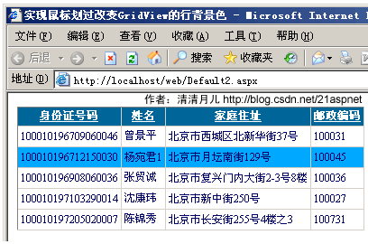
做法：
双击GridView的OnRowDataBound事件；
在后台的GridView1_RowDataBound()方法添加代码，最后代码如下所示：
protected void GridView1_RowDataBound(object sender, GridViewRowEventArgs e)
{
int i;
//执行循环，保证每条数据都可以更新
for (i = 0; i < GridView1.Rows.Count; i++)
{
//首先判断是否是数据行
if (e.Row.RowType == DataControlRowType.DataRow)
{
//当鼠标停留时更改背景色
e.Row.Attributes.Add("onmouseover", "c=this.style.backgroundColor;this.style.backgroundColor='#00A9FF'");
//当鼠标移开时还原背景色
e.Row.Attributes.Add("onmouseout", "this.style.backgroundColor=c");
}
}

}

前台代码：
<html xmlns="http://www.w3.org/1999/xhtml" >
<head runat="server">
<title>实现鼠标划过改变GridView的行背景色 清清月儿http://blog.csdn.net/21aspnet </title>
</head>
<body>
<form id="form1" runat="server">
<div>
<asp:GridView ID="GridView1" runat="server" AutoGenerateColumns="False" DataKeyNames="身份证号码"
DataSourceID="SqlDataSource1" AllowSorting="True" BackColor="White" BorderColor="#CCCCCC" BorderStyle="None" BorderWidth="1px" CellPadding="3" Font-Size="12px" OnRowDataBound="GridView1_RowDataBound">
<Columns>
<asp:BoundField DataField="身份证号码" HeaderText="身份证号码" ReadOnly="True" SortExpression="身份证号码" />
<asp:BoundField DataField="姓名" HeaderText="姓名" SortExpression="姓名" />
<asp:BoundField DataField="家庭住址" HeaderText="家庭住址" SortExpression="家庭住址" />
<asp:BoundField DataField="邮政编码" HeaderText="邮政编码" SortExpression="邮政编码" />
</Columns>
<FooterStyle BackColor="White" ForeColor="#000066" />
<RowStyle ForeColor="#000066" />
<SelectedRowStyle BackColor="#669999" Font-Bold="True" ForeColor="White" />
<PagerStyle BackColor="White" ForeColor="#000066" HorizontalAlign="Left" />
<HeaderStyle BackColor="#006699" Font-Bold="True" ForeColor="White" />
</asp:GridView>
<asp:SqlDataSource ID="SqlDataSource1" runat="server" ConnectionString="<%$ ConnectionStrings:北风贸易ConnectionString1 %>"
SelectCommand="SELECT top 5 [身份证号码], [姓名], [员工性别], [家庭住址], [邮政编码] FROM [飞狐工作室]" DataSourceMode="DataReader"></asp:SqlDataSource>

</div>
</form>
</body>
</html>

7.鼠标移到GridView某一行时改变该行的背景色方法二：

效果图：
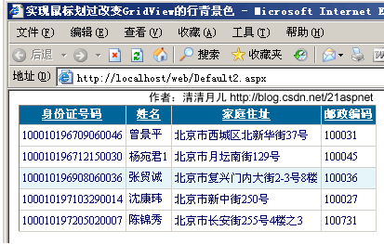
做法：和上面的一样就是代码不同
protected void GridView1_RowDataBound(object sender, GridViewRowEventArgs e)
{
//int i;
////执行循环，保证每条数据都可以更新
//for (i = 0; i < GridView1.Rows.Count; i++)
//{
// //首先判断是否是数据行
// if (e.Row.RowType == DataControlRowType.DataRow)
// {
// //当鼠标停留时更改背景色
// e.Row.Attributes.Add("onmouseover", "c=this.style.backgroundColor;this.style.backgroundColor='#00A9FF'");
// //当鼠标移开时还原背景色
// e.Row.Attributes.Add("onmouseout", "this.style.backgroundColor=c");
// }
//}
//如果是绑定数据行
if (e.Row.RowType == DataControlRowType.DataRow)
{
//鼠标经过时，行背景色变
e.Row.Attributes.Add("onmouseover", "this.style.backgroundColor='#E6F5FA'");
//鼠标移出时，行背景色变
e.Row.Attributes.Add("onmouseout", "this.style.backgroundColor='#FFFFFF'");
}

}

8.GridView实现删除时弹出确认对话框：

效果图：
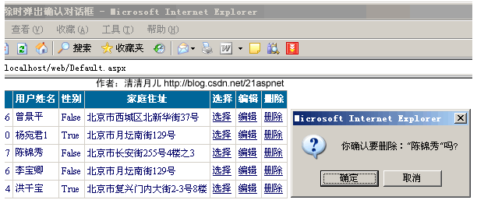
实现方法：
双击GridView的OnRowDataBound事件；
在后台的GridView1_RowDataBound()方法添加代码，最后代码如下所示：

protected void GridView1_RowDataBound(object sender, GridViewRowEventArgs e)
{
//如果是绑定数据行
if (e.Row.RowType == DataControlRowType.DataRow)
{
if (e.Row.RowState == DataControlRowState.Normal || e.Row.RowState == DataControlRowState.Alternate)
{
((LinkButton)e.Row.Cells[6].Controls[0]).Attributes.Add("onclick", "javascript:return confirm('你确认要删除：\"" + e.Row.Cells[1].Text + "\"吗?')");
}
}

}

9.GridView实现自动编号：

效果图：
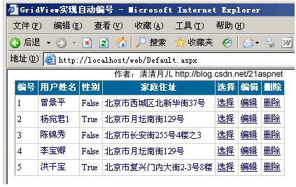

实现方法：
双击GridView的OnRowDataBound事件；
在后台的GridView1_RowDataBound()方法添加代码，最后代码如下所示：
protected void GridView1_RowDataBound(object sender, GridViewRowEventArgs e)
{
//如果是绑定数据行 //清清月儿http://blog.csdn.net/21aspnet
if (e.Row.RowType == DataControlRowType.DataRow)
{
////鼠标经过时，行背景色变
//e.Row.Attributes.Add("onmouseover", "this.style.backgroundColor='#E6F5FA'");
////鼠标移出时，行背景色变
//e.Row.Attributes.Add("onmouseout", "this.style.backgroundColor='#FFFFFF'");

////当有编辑列时，避免出错，要加的RowState判断
//if (e.Row.RowState == DataControlRowState.Normal || e.Row.RowState == DataControlRowState.Alternate)
//{
// ((LinkButton)e.Row.Cells[6].Controls[0]).Attributes.Add("onclick", "javascript:return confirm('你确认要删除：\"" + e.Row.Cells[1].Text + "\"吗?')");
//}

}
if (e.Row.RowIndex != -1)
{
int id = e.Row.RowIndex + 1;
e.Row.Cells[0].Text = id.ToString();
}

}

注意这时最好把前台的第一列的表头该为“编号”，因为以前的第一列被“吃掉”了。
<asp:GridView ID="GridView1" runat="server" AutoGenerateColumns="False" CellPadding="3" OnRowDeleting="GridView1_RowDeleting" OnRowEditing="GridView1_RowEditing"
OnRowUpdating="GridView1_RowUpdating" OnRowCancelingEdit="GridView1_RowCancelingEdit" BackColor="White" BorderColor="#CCCCCC" BorderStyle="None" BorderWidth="1px" Font-Size="12px" OnRowDataBound="GridView1_RowDataBound">
<FooterStyle BackColor="White" ForeColor="#000066" />
<Columns>
<asp:BoundField DataField="身份证号码" HeaderText="编号" ReadOnly="True" />
<asp:BoundField DataField="姓名" HeaderText="用户姓名" />
<asp:BoundField DataField="员工性别" HeaderText="性别" />
<asp:BoundField DataField="家庭住址" HeaderText="家庭住址" />
<asp:CommandField HeaderText="选择" ShowSelectButton="True" />
<asp:CommandField HeaderText="编辑" ShowEditButton="True" />
<asp:CommandField HeaderText="删除" ShowDeleteButton="True" />
</Columns>
<RowStyle ForeColor="#000066" />
<SelectedRowStyle BackColor="#669999" Font-Bold="True" ForeColor="White" />
<PagerStyle BackColor="White" ForeColor="#000066" HorizontalAlign="Left" />
<HeaderStyle BackColor="#006699" Font-Bold="True" ForeColor="White" />
</asp:GridView>

10.GridView实现自定义时间货币等字符串格式：

效果图：
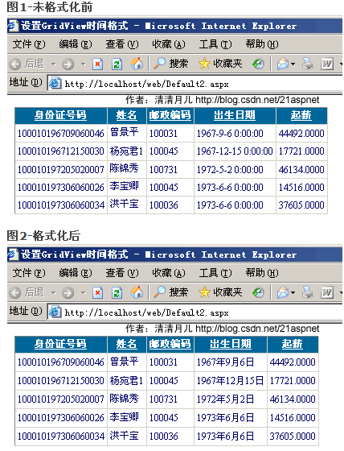解决方法：
在asp.net 2.0中，如果要在绑定列中显示比如日期格式等，如果用下面的方法是显示不了的

<asp :BoundField DataField="CreationDate"
DataFormatString="{0:M-dd-yyyy}"
HeaderText="CreationDate" />

主要是由于htmlencode属性默认设置为true,已防止XSS攻击，安全起见而用的，所以，可以有以下两种方法解决

1、

<asp :GridView ID="GridView1" runat="server">
<columns>
<asp :BoundField DataField="CreationDate"
DataFormatString="{0:M-dd-yyyy}"
HtmlEncode="false"
HeaderText="CreationDate" />
</columns>
</asp>

将htmlencode设置为false即可

另外的解决方法为，使用模版列

<asp :GridView ID="GridView3" runat="server" >
<columns>
<asp :TemplateField HeaderText="CreationDate" >
<edititemtemplate>
<asp :Label ID="Label1" runat="server"
Text='<%# Eval("CreationDate", "{0:M-dd-yyyy}") %>'>
</asp>
</edititemtemplate>
<itemtemplate>
<asp :Label ID="Label1" runat="server"
Text=’<%# Bind("CreationDate", "{0:M-dd-yyyy}") %>'>
</asp>
</itemtemplate>
</asp>
</columns>
</asp>

前台代码：
<asp:GridView ID="GridView1" runat="server" AutoGenerateColumns="False" DataKeyNames="身份证号码"
DataSourceID="SqlDataSource1" AllowSorting="True" BackColor="White" BorderColor="#CCCCCC" BorderStyle="None" BorderWidth="1px" CellPadding="3" Font-Size="12px" OnRowDataBound="GridView1_RowDataBound">
<Columns>
<asp:BoundField DataField="身份证号码" HeaderText="身份证号码" ReadOnly="True" SortExpression="身份证号码" />
<asp:BoundField DataField="姓名" HeaderText="姓名" SortExpression="姓名" />
<asp:BoundField DataField="邮政编码" HeaderText="邮政编码" SortExpression="邮政编码" />
<asp:BoundField DataField="出生日期" HeaderText="出生日期" SortExpression="出生日期" />
<asp:BoundField DataField="起薪" HeaderText="起薪" SortExpression="起薪" />
</Columns>
<FooterStyle BackColor="White" ForeColor="#000066" />
<RowStyle ForeColor="#000066" />
<SelectedRowStyle BackColor="#669999" Font-Bold="True" ForeColor="White" />
<PagerStyle BackColor="White" ForeColor="#000066" HorizontalAlign="Left" />
<HeaderStyle BackColor="#006699" Font-Bold="True" ForeColor="White" />
</asp:GridView>
<asp:SqlDataSource ID="SqlDataSource1" runat="server" ConnectionString="<%$ ConnectionStrings:北风贸易ConnectionString1 %>"
SelectCommand="SELECT top 5 [出生日期], [起薪], [身份证号码], [姓名], [家庭住址], [邮政编码] FROM [飞狐工作室]" DataSourceMode="DataReader"></asp:SqlDataSource>

附录-常用格式化公式：
{0:C} 货币；
{0:D4}由0填充的4个字符宽的字段中显示整数；
{0:000.0}四舍五入小数点保留第几位有效数字；
{0:N2}小数点保留2位有效数字；{0:N2}% 小数点保留2位有效数字加百分号；
{0:D}长日期；{0:d}短日期；{0:yy-MM-dd} 例如07-3-25；；{0:yyyy-MM-dd} 例如2007-3-25

11.GridView实现用“...”代替超长字符串：

效果图：
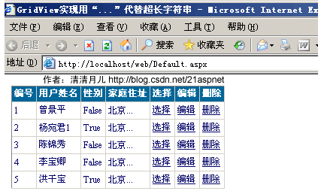
解决方法：数据绑定后过滤每一行即可
for (int i = 0; i <= GridView1.Rows.Count - 1; i++)
{
DataRowView mydrv;
string gIntro;
if (GridView1.PageIndex == 0)
{
mydrv = myds.Tables["飞狐工作室"].DefaultView[i];//表名
gIntro = Convert.ToString(mydrv["家庭住址"]);//所要处理的字段
GridView1.Rows[i].Cells[3].Text = SubStr(gIntro, 2);
}
else
{
mydrv = myds.Tables["飞狐工作室"].DefaultView[i + (5 * GridView1.PageIndex)];
gIntro = Convert.ToString(mydrv["家庭住址"]);
GridView1.Rows[i].Cells[3].Text = SubStr(gIntro, 2);
}
}

调用的方法：

public string SubStr(string sString, int nLeng)
{
if (sString.Length <= nLeng)
{
return sString;
}
string sNewStr = sString.Substring(0, nLeng);
sNewStr = sNewStr + "...";
return sNewStr;
}

后台全部代码：
using System;
using System.Data;
using System.Configuration;
using System.Web;
using System.Web.Security;
using System.Web.UI;
using System.Web.UI.WebControls;
using System.Web.UI.WebControls.WebParts;
using System.Web.UI.HtmlControls;
using System.Data.SqlClient;

public partial class _Default : System.Web.UI.Page
{
SqlConnection sqlcon;
SqlCommand sqlcom;
string strCon = "Data Source=(local);Database=北风贸易;Uid=sa;Pwd=sa";
protected void Page_Load(object sender, EventArgs e)
{
if (!IsPostBack)
{
ViewState["SortOrder"] = "身份证号码";
ViewState["OrderDire"] = "ASC";
bind();
}
}
protected void GridView1_RowEditing(object sender, GridViewEditEventArgs e)
{
GridView1.EditIndex = e.NewEditIndex;
bind();
}
protected void GridView1_RowDeleting(object sender, GridViewDeleteEventArgs e)
{
string sqlstr = "delete from 飞狐工作室 where 身份证号码='" + GridView1.DataKeys[e.RowIndex].Value.ToString() + "'";
sqlcon = new SqlConnection(strCon);
sqlcom = new SqlCommand(sqlstr,sqlcon);
sqlcon.Open();
sqlcom.ExecuteNonQuery();
sqlcon.Close();
bind();
}
protected void GridView1_RowUpdating(object sender, GridViewUpdateEventArgs e)
{
sqlcon = new SqlConnection(strCon);
string sqlstr = "update 飞狐工作室 set 姓名='"
+ ((TextBox)(GridView1.Rows[e.RowIndex].Cells[1].Controls[0])).Text.ToString().Trim() + "',家庭住址='"
+ ((TextBox)(GridView1.Rows[e.RowIndex].Cells[3].Controls[0])).Text.ToString().Trim() + "' where 身份证号码='"
+ GridView1.DataKeys[e.RowIndex].Value.ToString() + "'";
sqlcom=new SqlCommand(sqlstr,sqlcon);
sqlcon.Open();
sqlcom.ExecuteNonQuery();
sqlcon.Close();
GridView1.EditIndex = -1;
bind();
}
protected void GridView1_RowCancelingEdit(object sender, GridViewCancelEditEventArgs e)
{
GridView1.EditIndex = -1;
bind();
}
public void bind()
{
string sqlstr = "select top 5 * from 飞狐工作室";
sqlcon = new SqlConnection(strCon);
SqlDataAdapter myda = new SqlDataAdapter(sqlstr, sqlcon);
DataSet myds = new DataSet();
sqlcon.Open();
myda.Fill(myds, "飞狐工作室");
GridView1.DataSource = myds;
GridView1.DataKeyNames = new string[] { "身份证号码" };
GridView1.DataBind();
for (int i = 0; i <= GridView1.Rows.Count - 1; i++)
{
DataRowView mydrv;
string gIntro;
if (GridView1.PageIndex == 0)
{
mydrv = myds.Tables["飞狐工作室"].DefaultView[i];
gIntro = Convert.ToString(mydrv["家庭住址"]);
GridView1.Rows[i].Cells[3].Text = SubStr(gIntro, 2);
}
else
{
mydrv = myds.Tables["飞狐工作室"].DefaultView[i + (5 * GridView1.PageIndex)];
gIntro = Convert.ToString(mydrv["家庭住址"]);
GridView1.Rows[i].Cells[3].Text = SubStr(gIntro, 2);
}
}

sqlcon.Close();
}
public string SubStr(string sString, int nLeng)
{
if (sString.Length <= nLeng)
{
return sString;
}
string sNewStr = sString.Substring(0, nLeng);
sNewStr = sNewStr + "...";
return sNewStr;
}
protected void GridView1_RowDataBound(object sender, GridViewRowEventArgs e)
{
//如果是绑定数据行
if (e.Row.RowType == DataControlRowType.DataRow)
{
////鼠标经过时，行背景色变
//e.Row.Attributes.Add("onmouseover", "this.style.backgroundColor='#E6F5FA'");
////鼠标移出时，行背景色变
//e.Row.Attributes.Add("onmouseout", "this.style.backgroundColor='#FFFFFF'");

////当有编辑列时，避免出错，要加的RowState判断
//if (e.Row.RowState == DataControlRowState.Normal || e.Row.RowState == DataControlRowState.Alternate)
//{
// ((LinkButton)e.Row.Cells[6].Controls[0]).Attributes.Add("onclick", "javascript:return confirm('你确认要删除：\"" + e.Row.Cells[1].Text + "\"吗?')");
//}

}
if (e.Row.RowIndex != -1)
{
int id = e.Row.RowIndex + 1;
e.Row.Cells[0].Text = id.ToString();
}

}
}

12.GridView一般换行与强制换行：

效果图：
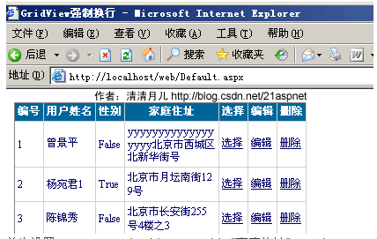
首先设置<asp:BoundField DataField="家庭住址" HeaderText="家庭住址" ItemStyle-Width="100" />
gridview里有一列绑定的数据很长，显示的时候在一行里面显示，页面拉得很宽。
原因是连续英文段为一个整体导致的，在RowDataBound中添加上了一句e.Row.Cells[2].Style.Add("word-break", "break-all")就可以。

如果要给所有的列增加此属性：
protected void Page_Load(object sender, EventArgs e)
{
//正常换行
GridView1.Attributes.Add("style", "word-break:keep-all;word-wrap:normal");
//下面这行是自动换行
GridView1.Attributes.Add("style", "word-break:break-all;word-wrap:break-word");
if (!IsPostBack)
{
bind();//调用数据绑定即可
}
}
总之：善用CSS的word-break:break-all;word-wrap:break-word属性即可，这个属性是通用的对于顽固的南换行问题都可以解决，不局限于GridView。

13.GridView显示隐藏某一列：
本方案为月儿独创，不同于网上其他方式，我觉得用一个CheckBox更人性化，这样可以隐藏不必要的列，让用户自己选择需要出现的列，在处理多列时这是一个很好的解决方案！

效果图：
图1-开始
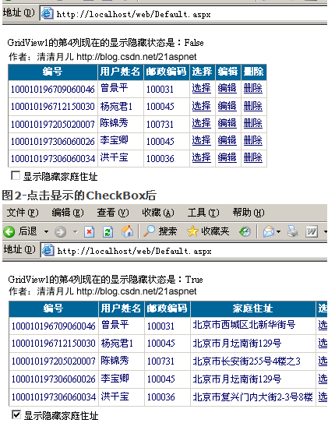
解决方案：
public void bind()
{
string sqlstr = "select top 5 * from 飞狐工作室";
sqlcon = new SqlConnection(strCon);
SqlDataAdapter myda = new SqlDataAdapter(sqlstr, sqlcon);
DataSet myds = new DataSet();
sqlcon.Open();
myda.Fill(myds, "飞狐工作室");
GridView1.DataSource = myds;
GridView1.DataKeyNames = new string[] { "身份证号码" };
GridView1.DataBind();
sqlcon.Close();
GridView1.Columns[3].Visible = false;//一开始隐藏
CheckBox1.Checked = false;//如果不这样后面的代码会把他True
}

双击CheckBox1，在CheckedChanged方法里写上代码，最后代码如下：
protected void CheckBox1_CheckedChanged(object sender, EventArgs e)
{
GridView1.Columns[3].Visible=! GridView1.Columns[3].Visible;
Response.Write("GridView1的第4列现在的显示隐藏状态是："+GridView1.Columns[3].Visible.ToString());
}

注意：CheckBox1的AutoPostBack要True！

后台全部代码如下：

using System;
using System.Data;
using System.Configuration;
using System.Web;
using System.Web.Security;
using System.Web.UI;
using System.Web.UI.WebControls;
using System.Web.UI.WebControls.WebParts;
using System.Web.UI.HtmlControls;
using System.Data.SqlClient;

public partial class _Default : System.Web.UI.Page
{
SqlConnection sqlcon;
SqlCommand sqlcom;
string strCon = "Data Source=(local);Database=北风贸易;Uid=sa;Pwd=sa";
protected void Page_Load(object sender, EventArgs e)
{
if (!IsPostBack)
{
ViewState["SortOrder"] = "身份证号码";
ViewState["OrderDire"] = "ASC";
bind();
}
}
protected void GridView1_RowEditing(object sender, GridViewEditEventArgs e)
{
GridView1.EditIndex = e.NewEditIndex;
bind();
}
protected void GridView1_RowDeleting(object sender, GridViewDeleteEventArgs e)
{
string sqlstr = "delete from 飞狐工作室 where 身份证号码='" + GridView1.DataKeys[e.RowIndex].Value.ToString() + "'";
sqlcon = new SqlConnection(strCon);
sqlcom = new SqlCommand(sqlstr,sqlcon);
sqlcon.Open();
sqlcom.ExecuteNonQuery();
sqlcon.Close();
bind();
}
protected void GridView1_RowUpdating(object sender, GridViewUpdateEventArgs e)
{
sqlcon = new SqlConnection(strCon);
string sqlstr = "update 飞狐工作室 set 姓名='"
+ ((TextBox)(GridView1.Rows[e.RowIndex].Cells[1].Controls[0])).Text.ToString().Trim() + "',家庭住址='"
+ ((TextBox)(GridView1.Rows[e.RowIndex].Cells[3].Controls[0])).Text.ToString().Trim() + "' where 身份证号码='"
+ GridView1.DataKeys[e.RowIndex].Value.ToString() + "'";
sqlcom=new SqlCommand(sqlstr,sqlcon);
sqlcon.Open();
sqlcom.ExecuteNonQuery();
sqlcon.Close();
GridView1.EditIndex = -1;
bind();
}
protected void GridView1_RowCancelingEdit(object sender, GridViewCancelEditEventArgs e)
{
GridView1.EditIndex = -1;
bind();
}
public void bind()
{
string sqlstr = "select top 5 * from 飞狐工作室";
sqlcon = new SqlConnection(strCon);
SqlDataAdapter myda = new SqlDataAdapter(sqlstr, sqlcon);
DataSet myds = new DataSet();
sqlcon.Open();
myda.Fill(myds, "飞狐工作室");
GridView1.DataSource = myds;
GridView1.DataKeyNames = new string[] { "身份证号码" };
GridView1.DataBind();
sqlcon.Close();
GridView1.Columns[3].Visible = false;
CheckBox1.Checked = false;
}
protected void CheckBox1_CheckedChanged(object sender, EventArgs e)
{
GridView1.Columns[3].Visible=! GridView1.Columns[3].Visible;
Response.Write("GridView1的第4列现在的显示隐藏状态是："+GridView1.Columns[3].Visible.ToString());
}
}

前台代码：
<!DOCTYPE html PUBLIC "-//W3C//DTD XHTML 1.0 Transitional//EN" "http://www.w3.org/TR/xhtml1/DTD/xhtml1-transitional.dtd">

<html xmlns="http://www.w3.org/1999/xhtml" >
<head runat="server">
<title>GridView显示隐藏列 清清月儿http://blog.csdn.net/21aspnet </title>
</head>
<body style="font-size=12px">
<form id="form1" runat="server">
<div>
<asp:GridView ID="GridView1" runat="server" AutoGenerateColumns="False" CellPadding="3" OnRowDeleting="GridView1_RowDeleting" OnRowEditing="GridView1_RowEditing"
OnRowUpdating="GridView1_RowUpdating" OnRowCancelingEdit="GridView1_RowCancelingEdit" BackColor="White" BorderColor="#CCCCCC" BorderStyle="None" BorderWidth="1px" Font-Size="12px" >
<FooterStyle BackColor="White" ForeColor="#000066" />
<Columns>
<asp:BoundField DataField="身份证号码" HeaderText="编号" ReadOnly="True" />
<asp:BoundField DataField="姓名" HeaderText="用户姓名" />
<asp:BoundField DataField="邮政编码" HeaderText="邮政编码" SortExpression="邮政编码" />
<asp:BoundField DataField="家庭住址" HeaderText="家庭住址" />
<asp:CommandField HeaderText="选择" ShowSelectButton="True" />
<asp:CommandField HeaderText="编辑" ShowEditButton="True" />
<asp:CommandField HeaderText="删除" ShowDeleteButton="True" />
</Columns>
<RowStyle ForeColor="#000066" />
<SelectedRowStyle BackColor="#669999" Font-Bold="True" ForeColor="White" />
<PagerStyle BackColor="White" ForeColor="#000066" HorizontalAlign="Left" />
<HeaderStyle BackColor="#006699" Font-Bold="True" ForeColor="White" />
</asp:GridView>
<asp:CheckBox ID="CheckBox1" runat="server" AutoPostBack="True" Font-Size="12px"
OnCheckedChanged="CheckBox1_CheckedChanged" Text="显示隐藏家庭住址" /></div>
</form>
</body>
</html>

14.GridView弹出新页面/弹出制定大小位置新窗口：

效果图：
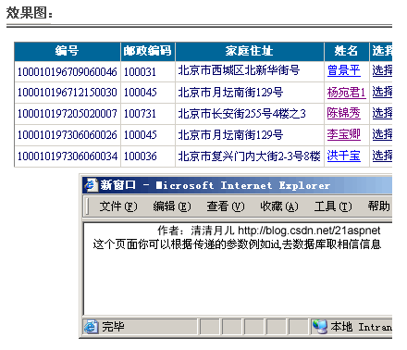
方案一：简单的方法，新窗口不固定大小
<asp:GridView ID="GridView1" runat="server" AutoGenerateColumns="False" CellPadding="3" OnRowDeleting="GridView1_RowDeleting" OnRowEditing="GridView1_RowEditing"
OnRowUpdating="GridView1_RowUpdating" OnRowCancelingEdit="GridView1_RowCancelingEdit" BackColor="White" BorderColor="#CCCCCC" BorderStyle="None" BorderWidth="1px" Font-Size="12px" >
<FooterStyle BackColor="White" ForeColor="#000066" />
<Columns>
<asp:BoundField DataField="身份证号码" HeaderText="编号" ReadOnly="True" />
<asp:BoundField DataField="邮政编码" HeaderText="邮政编码" SortExpression="邮政编码" />
<asp:BoundField DataField="家庭住址" HeaderText="家庭住址" />
<asp:HyperLinkField HeaderText="姓名" Text="姓名" DataNavigateUrlFields="姓名" DataNavigateUrlFormatString="Default6.aspx?GoodsID={0}" Target="mainframe" NavigateUrl="~/Default6.aspx" DataTextField="姓名" >
</asp:HyperLinkField>
<asp:CommandField HeaderText="选择" ShowSelectButton="True" />
<asp:CommandField HeaderText="编辑" ShowEditButton="True" />
<asp:CommandField HeaderText="删除" ShowDeleteButton="True" />
</Columns>
<RowStyle ForeColor="#000066" />
<SelectedRowStyle BackColor="#669999" Font-Bold="True" ForeColor="White" />
<PagerStyle BackColor="White" ForeColor="#000066" HorizontalAlign="Left" />
<HeaderStyle BackColor="#006699" Font-Bold="True" ForeColor="White" />
</asp:GridView>
DataNavigateUrlFields是链接的字段名，DataNavigateUrlFormatString是路径。

方案二：精确控制弹出窗口大小位置
<asp:HyperLinkColumn DataNavigateUrlField="EmployeeID" DataNavigateUrlFormatString="javascript:varwin=window.open('detail.aspx?ID={0}',null,'width=300,height=200');window.Close();"
DataTextField="LastName" HeaderText="LastName"></asp:HyperLinkColumn>

使用的是结合javascript的window.open方法，关于window.open的参数网上有很多帖子，本站也有许多参考
弹出窗口大全 http://blog.csdn.net/21aspnet/archive/2004/10/25/150231.aspx 即可！

15.GridView固定表头(不用javascript只用CSS!，很好用)：

效果图：
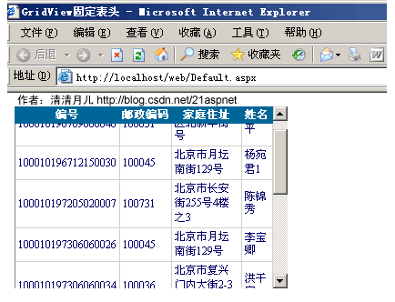
代码：
<!DOCTYPE html PUBLIC "-//W3C//DTD XHTML 1.0 Transitional//EN" "http://www.w3.org/TR/xhtml1/DTD/xhtml1-transitional.dtd">

<html xmlns="http://www.w3.org/1999/xhtml" >
<head runat="server">
<title>GridView固定表头 清清月儿http://blog.csdn.net/21aspnet </title>
<style>
.Freezing
{

position:relative ;
table-layout:fixed;
top:expression(this.offsetParent.scrollTop);
z-index: 10;
}

.Freezing th{text-overflow:ellipsis;overflow:hidden;white-space: nowrap;padding:2px;}
</style>
</head>
<body style="font-size=12px">
<form id="form1" runat="server">
<div style="overflow-y: scroll; height: 200px;width:300px" id="dvBody">
<asp:GridView ID="GridView1" runat="server" AutoGenerateColumns="False" CellPadding="3" OnRowDeleting="GridView1_RowDeleting" OnRowEditing="GridView1_RowEditing"
OnRowUpdating="GridView1_RowUpdating" OnRowCancelingEdit="GridView1_RowCancelingEdit" BackColor="White" BorderColor="#CCCCCC" BorderStyle="None" BorderWidth="1px" Font-Size="12px" OnRowCreated="GridView1_RowCreated" >
<FooterStyle BackColor="White" ForeColor="#000066" />
<Columns>
<asp:BoundField DataField="身份证号码" HeaderText="编号" ReadOnly="True" />
<asp:BoundField DataField="邮政编码" HeaderText="邮政编码" SortExpression="邮政编码" />
<asp:BoundField DataField="家庭住址" HeaderText="家庭住址" />
<asp:BoundField DataField="姓名" HeaderText="姓名" />

</Columns>
<RowStyle ForeColor="#000066" />
<SelectedRowStyle BackColor="#669999" Font-Bold="True" ForeColor="White" />
<PagerStyle BackColor="White" ForeColor="#000066" HorizontalAlign="Left" CssClass="ms-formlabel DataGridFixedHeader"/>
<HeaderStyle BackColor="#006699" Font-Bold="True" ForeColor="White" CssClass="Freezing"/>
</asp:GridView>
</div>

</form>
</body>
</html>

用法：CSS设如上的样式，HeaderStyle加CssClass="Freezing，套住GridView的Div设置高度宽度 <div style="overflow-y: scroll; height: 200px;width:200px" >

16.GridView合并表头多重表头无错完美版（以合并3列3行举例）
效果图：
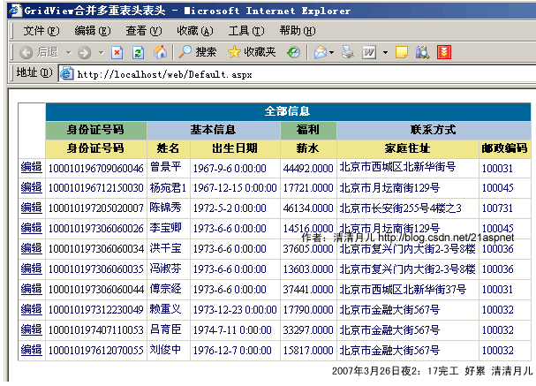
后台代码：
using System;
using System.Data;
using System.Configuration;
using System.Web;
using System.Web.Security;
using System.Web.UI;
using System.Web.UI.WebControls;
using System.Web.UI.WebControls.WebParts;
using System.Web.UI.HtmlControls;
using System.Data.SqlClient;
using System.Drawing;
public partial class _Default : System.Web.UI.Page
{
SqlConnection sqlcon;
SqlCommand sqlcom;
string strCon = "Data Source=(local);Database=北风贸易;Uid=sa;Pwd=sa";
protected void Page_Load(object sender, EventArgs e)
{
if (!IsPostBack)
{
bind();

}
}
protected void GridView1_RowEditing(object sender, GridViewEditEventArgs e)
{
GridView1.EditIndex = e.NewEditIndex;
bind();
}
protected void GridView1_RowUpdating(object sender, GridViewUpdateEventArgs e)
{
sqlcon = new SqlConnection(strCon);
string sqlstr = "update 飞狐工作室 set 姓名='"
+ ((TextBox)(GridView1.Rows[e.RowIndex].Cells[1].Controls[0])).Text.ToString().Trim() + "',家庭住址='"
+ ((TextBox)(GridView1.Rows[e.RowIndex].Cells[3].Controls[0])).Text.ToString().Trim() + "' where 身份证号码='"
+ GridView1.DataKeys[e.RowIndex].Value.ToString() + "'";
sqlcom=new SqlCommand(sqlstr,sqlcon);
sqlcon.Open();
sqlcom.ExecuteNonQuery();
sqlcon.Close();
GridView1.EditIndex = -1;
bind();
}
protected void GridView1_RowCancelingEdit(object sender, GridViewCancelEditEventArgs e)
{
GridView1.EditIndex = -1;
bind();
}
public void bind()
{
string sqlstr = "select top 10 * from 飞狐工作室";
sqlcon = new SqlConnection(strCon);
SqlDataAdapter myda = new SqlDataAdapter(sqlstr, sqlcon);
DataSet myds = new DataSet();
sqlcon.Open();
myda.Fill(myds, "飞狐工作室");
GridView1.DataSource = myds;
GridView1.DataKeyNames = new string[] { "身份证号码" };
GridView1.DataBind();
sqlcon.Close();
}

//这里就是解决方案
protected void GridView1_RowCreated(object sender, GridViewRowEventArgs e)
{
switch (e.Row.RowType)
{
case DataControlRowType.Header:
//第一行表头
TableCellCollection tcHeader = e.Row.Cells;
tcHeader.Clear();
tcHeader.Add(new TableHeaderCell());
tcHeader[0].Attributes.Add("rowspan", "3"); //跨Row
tcHeader[0].Attributes.Add("bgcolor", "white");
tcHeader[0].Text = "";
tcHeader.Add(new TableHeaderCell());
//tcHeader[1].Attributes.Add("bgcolor", "Red");
tcHeader[1].Attributes.Add("colspan", "6"); //跨Column
tcHeader[1].Text = "全部信息</th></tr><tr>";

//第二行表头
tcHeader.Add(new TableHeaderCell());
tcHeader[2].Attributes.Add("bgcolor", "DarkSeaGreen");
tcHeader[2].Text = "身份证号码";
tcHeader.Add(new TableHeaderCell());
tcHeader[3].Attributes.Add("bgcolor", "LightSteelBlue");
tcHeader[3].Attributes.Add("colspan", "2");
tcHeader[3].Text = "基本信息";
tcHeader.Add(new TableHeaderCell());
tcHeader[4].Attributes.Add("bgcolor", "DarkSeaGreen");
tcHeader[4].Text = "福利";
tcHeader.Add(new TableHeaderCell());
tcHeader[5].Attributes.Add("bgcolor", "LightSteelBlue");
tcHeader[5].Attributes.Add("colspan", "2");
tcHeader[5].Text = "联系方式</th></tr><tr>";

//第三行表头
tcHeader.Add(new TableHeaderCell());
tcHeader[6].Attributes.Add("bgcolor", "Khaki");
tcHeader[6].Text = "身份证号码";
tcHeader.Add(new TableHeaderCell());
tcHeader[7].Attributes.Add("bgcolor", "Khaki");
tcHeader[7].Text = "姓名";
tcHeader.Add(new TableHeaderCell());
tcHeader[8].Attributes.Add("bgcolor", "Khaki");
tcHeader[8].Text = "出生日期";
tcHeader.Add(new TableHeaderCell());
tcHeader[9].Attributes.Add("bgcolor", "Khaki");
tcHeader[9].Text = "薪水";
tcHeader.Add(new TableHeaderCell());
tcHeader[10].Attributes.Add("bgcolor", "Khaki");
tcHeader[10].Text = "家庭住址";
tcHeader.Add(new TableHeaderCell());
tcHeader[11].Attributes.Add("bgcolor", "Khaki");
tcHeader[11].Text = "邮政编码";
break;
}
}
}

前台：
<!DOCTYPE html PUBLIC "-//W3C//DTD XHTML 1.0 Transitional//EN" "http://www.w3.org/TR/xhtml1/DTD/xhtml1-transitional.dtd">

<html xmlns="http://www.w3.org/1999/xhtml" >
<head runat="server">
<title>GridView合并多重表头表头 清清月儿http://blog.csdn.net/21aspnet </title>
</head>
<body >
<form id="form1" runat="server">
<div >
<asp:GridView ID="GridView1" runat="server" AutoGenerateColumns="False" CellPadding="3" OnRowEditing="GridView1_RowEditing"
OnRowUpdating="GridView1_RowUpdating" OnRowCancelingEdit="GridView1_RowCancelingEdit" BackColor="White" BorderColor="#CCCCCC" BorderStyle="None" BorderWidth="1px" Font-Size="12px" OnRowCreated="GridView1_RowCreated" >
<FooterStyle BackColor="White" ForeColor="#000066" />
<Columns>
<asp:CommandField HeaderText="编辑" ShowEditButton="True" />
<asp:BoundField DataField="身份证号码" HeaderText="编号" ReadOnly="True" />
<asp:BoundField DataField="姓名" HeaderText="姓名" />
<asp:BoundField DataField="出生日期" HeaderText="邮政编码" />
<asp:BoundField DataField="起薪" HeaderText="起薪" />
<asp:BoundField DataField="家庭住址" HeaderText="家庭住址" />
<asp:BoundField DataField="邮政编码" HeaderText="邮政编码" />

</Columns>
<RowStyle ForeColor="#000066" />
<SelectedRowStyle BackColor="#669999" Font-Bold="True" ForeColor="White" />
<PagerStyle BackColor="White" ForeColor="#000066" HorizontalAlign="Left" CssClass="ms-formlabel DataGridFixedHeader"/>
<HeaderStyle BackColor="#006699" Font-Bold="True" ForeColor="White" />
</asp:GridView>
</div>

</form>
</body>
</html>

17.GridView突出显示某一单元格（例如金额低于多少，分数不及格等）

效果图：
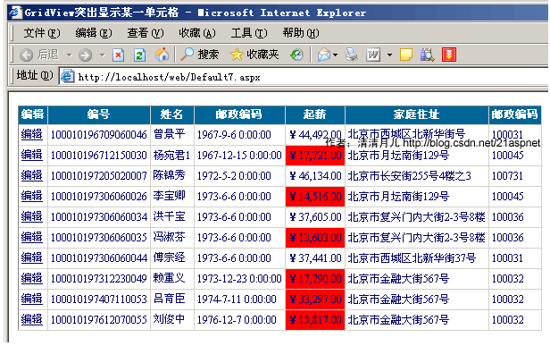
解决方案：主要是绑定后过滤
GridView1.DataBind();
for (int i = 0; i <= GridView1.Rows.Count - 1; i++)
{
DataRowView mydrv = myds.Tables["飞狐工作室"].DefaultView[i];
string score = Convert.ToString(mydrv["起薪"]);
if (Convert.ToDouble(score) < 34297.00)//大家这里根据具体情况设置可能ToInt32等等
{
GridView1.Rows[i].Cells[4].BackColor = System.Drawing.Color.Red;
}
}
sqlcon.Close();

全部后台代码：

using System;
using System.Data;
using System.Configuration;
using System.Web;
using System.Web.Security;
using System.Web.UI;
using System.Web.UI.WebControls;
using System.Web.UI.WebControls.WebParts;
using System.Web.UI.HtmlControls;
using System.Data.SqlClient;
using System.Drawing;

public partial class Default7 : System.Web.UI.Page
{
SqlConnection sqlcon;
SqlCommand sqlcom;
string strCon = "Data Source=(local);Database=北风贸易;Uid=sa;Pwd=sa";
protected void Page_Load(object sender, EventArgs e)
{
if (!IsPostBack)
{
bind();

}
}
protected void GridView1_RowEditing(object sender, GridViewEditEventArgs e)
{
GridView1.EditIndex = e.NewEditIndex;
bind();
}
protected void GridView1_RowUpdating(object sender, GridViewUpdateEventArgs e)
{
sqlcon = new SqlConnection(strCon);
string sqlstr = "update 飞狐工作室 set 姓名='"
+ ((TextBox)(GridView1.Rows[e.RowIndex].Cells[1].Controls[0])).Text.ToString().Trim() + "',家庭住址='"
+ ((TextBox)(GridView1.Rows[e.RowIndex].Cells[3].Controls[0])).Text.ToString().Trim() + "' where 身份证号码='"
+ GridView1.DataKeys[e.RowIndex].Value.ToString() + "'";
sqlcom = new SqlCommand(sqlstr, sqlcon);
sqlcon.Open();
sqlcom.ExecuteNonQuery();
sqlcon.Close();
GridView1.EditIndex = -1;
bind();
}
protected void GridView1_RowCancelingEdit(object sender, GridViewCancelEditEventArgs e)
{
GridView1.EditIndex = -1;
bind();
}
public void bind()
{
string sqlstr = "select top 10 * from 飞狐工作室";
sqlcon = new SqlConnection(strCon);
SqlDataAdapter myda = new SqlDataAdapter(sqlstr, sqlcon);
DataSet myds = new DataSet();
sqlcon.Open();
myda.Fill(myds, "飞狐工作室");
GridView1.DataSource = myds;
GridView1.DataKeyNames = new string[] { "身份证号码" };
GridView1.DataBind();
for (int i = 0; i <= GridView1.Rows.Count - 1; i++)
{
DataRowView mydrv = myds.Tables["飞狐工作室"].DefaultView[i];
string score = Convert.ToString(mydrv["起薪"]);
if (Convert.ToDouble(score) < 34297.00)//大家这里根据具体情况设置可能ToInt32等等

{
GridView1.Rows[i].Cells[4].BackColor = System.Drawing.Color.Red;
}
}
sqlcon.Close();
}
}

前台代码：

<!DOCTYPE html PUBLIC "-//W3C//DTD XHTML 1.0 Transitional//EN" "http://www.w3.org/TR/xhtml1/DTD/xhtml1-transitional.dtd">

<html xmlns="http://www.w3.org/1999/xhtml" >
<head id="Head1" runat="server">
<title>GridView突出显示某一单元格 清清月儿http://blog.csdn.net/21aspnet </title>
</head>
<body >
<form id="form1" runat="server">
<div >
<asp:GridView ID="GridView1" runat="server" AutoGenerateColumns="False" CellPadding="3" OnRowEditing="GridView1_RowEditing"
OnRowUpdating="GridView1_RowUpdating" OnRowCancelingEdit="GridView1_RowCancelingEdit" BackColor="White" BorderColor="#CCCCCC" BorderStyle="None" BorderWidth="1px" Font-Size="12px" >
<FooterStyle BackColor="White" ForeColor="#000066" />
<Columns>
<asp:CommandField HeaderText="编辑" ShowEditButton="True" />
<asp:BoundField DataField="身份证号码" HeaderText="编号" ReadOnly="True" />
<asp:BoundField DataField="姓名" HeaderText="姓名" />
<asp:BoundField DataField="出生日期" HeaderText="邮政编码" />
<asp:BoundField DataField="起薪" HeaderText="起薪" DataFormatString="{0:C}" HtmlEncode="false"/>
<asp:BoundField DataField="家庭住址" HeaderText="家庭住址" />
<asp:BoundField DataField="邮政编码" HeaderText="邮政编码" />

</Columns>
<RowStyle ForeColor="#000066" />
<SelectedRowStyle BackColor="#669999" Font-Bold="True" ForeColor="White" />
<PagerStyle BackColor="White" ForeColor="#000066" HorizontalAlign="Left" CssClass="ms-formlabel DataGridFixedHeader"/>
<HeaderStyle BackColor="#006699" Font-Bold="True" ForeColor="White" />
</asp:GridView>
</div>

</form>
</body>
</html>

18.GridView加入自动求和求平均值小计
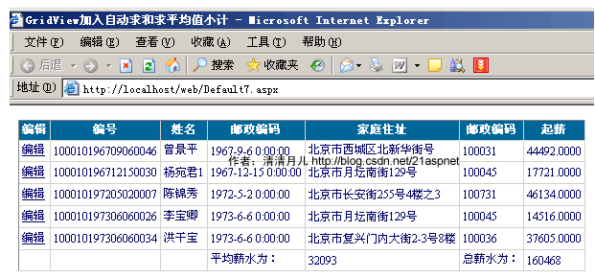
效果图：
解决方案：
private double sum = 0;//取指定列的数据和，你要根据具体情况对待可能你要处理的是int
protected void GridView1_RowDataBound(object sender, GridViewRowEventArgs e)
{

if (e.Row.RowIndex >= 0)
{
sum += Convert.ToDouble(e.Row.Cells[6].Text);
}
else if (e.Row.RowType == DataControlRowType.Footer)
{
e.Row.Cells[5].Text = "总薪水为：";
e.Row.Cells[6].Text = sum.ToString();
e.Row.Cells[3].Text = "平均薪水为：";
e.Row.Cells[4].Text = ((int)(sum / GridView1.Rows.Count)).ToString();

}
}

后台全部代码：
using System;
using System.Data;
using System.Configuration;
using System.Web;
using System.Web.Security;
using System.Web.UI;
using System.Web.UI.WebControls;
using System.Web.UI.WebControls.WebParts;
using System.Web.UI.HtmlControls;
using System.Data.SqlClient;
using System.Drawing;

public partial class Default7 : System.Web.UI.Page
{
SqlConnection sqlcon;
SqlCommand sqlcom;
string strCon = "Data Source=(local);Database=北风贸易;Uid=sa;Pwd=sa";
protected void Page_Load(object sender, EventArgs e)
{
if (!IsPostBack)
{
bind();

}
}
protected void GridView1_RowEditing(object sender, GridViewEditEventArgs e)
{
GridView1.EditIndex = e.NewEditIndex;
bind();
}
protected void GridView1_RowUpdating(object sender, GridViewUpdateEventArgs e)
{
sqlcon = new SqlConnection(strCon);
string sqlstr = "update 飞狐工作室 set 姓名='"
+ ((TextBox)(GridView1.Rows[e.RowIndex].Cells[1].Controls[0])).Text.ToString().Trim() + "',家庭住址='"
+ ((TextBox)(GridView1.Rows[e.RowIndex].Cells[3].Controls[0])).Text.ToString().Trim() + "' where 身份证号码='"
+ GridView1.DataKeys[e.RowIndex].Value.ToString() + "'";
sqlcom = new SqlCommand(sqlstr, sqlcon);
sqlcon.Open();
sqlcom.ExecuteNonQuery();
sqlcon.Close();
GridView1.EditIndex = -1;
bind();
}
protected void GridView1_RowCancelingEdit(object sender, GridViewCancelEditEventArgs e)
{
GridView1.EditIndex = -1;
bind();
}
public void bind()
{
string sqlstr = "select top 5 * from 飞狐工作室";
sqlcon = new SqlConnection(strCon);
SqlDataAdapter myda = new SqlDataAdapter(sqlstr, sqlcon);
DataSet myds = new DataSet();
sqlcon.Open();
myda.Fill(myds, "飞狐工作室");
GridView1.DataSource = myds;
GridView1.DataKeyNames = new string[] { "身份证号码" };
GridView1.DataBind();
sqlcon.Close();
}
private double sum = 0;//取指定列的数据和
protected void GridView1_RowDataBound(object sender, GridViewRowEventArgs e)
{

if (e.Row.RowIndex >= 0)
{
sum += Convert.ToDouble(e.Row.Cells[6].Text);
}
else if (e.Row.RowType == DataControlRowType.Footer)
{
e.Row.Cells[5].Text = "总薪水为：";
e.Row.Cells[6].Text = sum.ToString();
e.Row.Cells[3].Text = "平均薪水为：";
e.Row.Cells[4].Text = ((int)(sum / GridView1.Rows.Count)).ToString();

}
}
}
前台：唯一的花头就是设置ShowFooter="True" ，否则默认表头为隐藏的！
<asp:GridView ID="GridView1" runat="server" AutoGenerateColumns="False" CellPadding="3" OnRowEditing="GridView1_RowEditing"
OnRowUpdating="GridView1_RowUpdating" OnRowCancelingEdit="GridView1_RowCancelingEdit" BackColor="White" BorderColor="#CCCCCC" BorderStyle="None" BorderWidth="1px" Font-Size="12px" OnRowDataBound="GridView1_RowDataBound" ShowFooter="True" >
<FooterStyle BackColor="White" ForeColor="#000066" />
<Columns>
<asp:CommandField HeaderText="编辑" ShowEditButton="True" />
<asp:BoundField DataField="身份证号码" HeaderText="编号" ReadOnly="True" />
<asp:BoundField DataField="姓名" HeaderText="姓名" />
<asp:BoundField DataField="出生日期" HeaderText="邮政编码" />
<asp:BoundField DataField="家庭住址" HeaderText="家庭住址" />
<asp:BoundField DataField="邮政编码" HeaderText="邮政编码" />
<asp:BoundField DataField="起薪" HeaderText="起薪" />

</Columns>
<RowStyle ForeColor="#000066" />
<SelectedRowStyle BackColor="#669999" Font-Bold="True" ForeColor="White" />
<PagerStyle BackColor="White" ForeColor="#000066" HorizontalAlign="Left" CssClass="ms-formlabel DataGridFixedHeader"/>
<HeaderStyle BackColor="#006699" Font-Bold="True" ForeColor="White" />
</asp:GridView>

19.GridView数据导入Excel/Excel数据读入GridView

效果图：
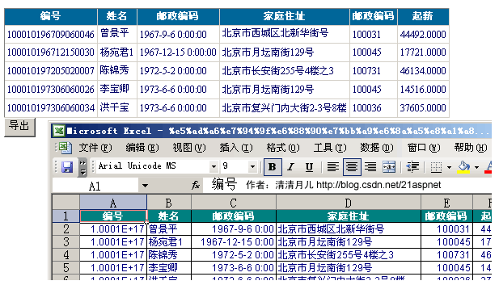

解决方案：
页面增加一个按钮，单击事件添加如下方法：
protected void Button1_Click(object sender, EventArgs e)
{
Export("application/ms-excel", "学生成绩报表.xls");
}

private void Export(string FileType, string FileName)
{
Response.Charset = "GB2312";
Response.ContentEncoding = System.Text.Encoding.UTF7;
Response.AppendHeader("Content-Disposition", "attachment;filename=" + HttpUtility.UrlEncode(FileName, Encoding.UTF8).ToString());
Response.ContentType = FileType;
this.EnableViewState = false;
StringWriter tw = new StringWriter();
HtmlTextWriter hw = new HtmlTextWriter(tw);
GridView1.RenderControl(hw);
Response.Write(tw.ToString());
Response.End();
}
//如果没有下面方法会报错类型“GridView”的控件“GridView1”必须放在具有 runat=server 的窗体标记内
public override void VerifyRenderingInServerForm(Control control)
{
}
还有由于是文件操作所以要引入名称空间IO和Text

后台代码：
using System;
using System.Data;
using System.Configuration;
using System.Web;
using System.Web.Security;
using System.Web.UI;
using System.Web.UI.WebControls;
using System.Web.UI.WebControls.WebParts;
using System.Web.UI.HtmlControls;
using System.Data.SqlClient;
using System.Drawing;
using System.IO;
using System.Text;
public partial class Default7 : System.Web.UI.Page
{
SqlConnection sqlcon;
SqlCommand sqlcom;
string strCon = "Data Source=(local);Database=北风贸易;Uid=sa;Pwd=sa";
protected void Page_Load(object sender, EventArgs e)
{
if (!IsPostBack)
{
bind();

}
}

public void bind()
{
string sqlstr = "select top 5 * from 飞狐工作室";
sqlcon = new SqlConnection(strCon);
SqlDataAdapter myda = new SqlDataAdapter(sqlstr, sqlcon);
DataSet myds = new DataSet();
sqlcon.Open();
myda.Fill(myds, "飞狐工作室");
GridView1.DataSource = myds;
GridView1.DataKeyNames = new string[] { "身份证号码" };
GridView1.DataBind();
sqlcon.Close();
}

protected void Button1_Click(object sender, EventArgs e)
{
Export("application/ms-excel", "学生成绩报表.xls");
}

private void Export(string FileType, string FileName)
{
Response.Charset = "GB2312";
Response.ContentEncoding = System.Text.Encoding.UTF7;
Response.AppendHeader("Content-Disposition", "attachment;filename=" + HttpUtility.UrlEncode(FileName, Encoding.UTF8).ToString());
Response.ContentType = FileType;
this.EnableViewState = false;
StringWriter tw = new StringWriter();
HtmlTextWriter hw = new HtmlTextWriter(tw);
GridView1.RenderControl(hw);
Response.Write(tw.ToString());
Response.End();
}
public override void VerifyRenderingInServerForm(Control control)
{
}

}

前台：
<asp:GridView ID="GridView1" runat="server" AutoGenerateColumns="False" CellPadding="3"
BackColor="White" BorderColor="#CCCCCC" BorderStyle="None" BorderWidth="1px" Font-Size="12px" >
<FooterStyle BackColor="White" ForeColor="#000066" />
<Columns>
<asp:BoundField DataField="身份证号码" HeaderText="编号" ReadOnly="True" />
<asp:BoundField DataField="姓名" HeaderText="姓名" />
<asp:BoundField DataField="出生日期" HeaderText="邮政编码" />
<asp:BoundField DataField="家庭住址" HeaderText="家庭住址" />
<asp:BoundField DataField="邮政编码" HeaderText="邮政编码" />
<asp:BoundField DataField="起薪" HeaderText="起薪" />

</Columns>
<RowStyle ForeColor="#000066" />
<SelectedRowStyle BackColor="#669999" Font-Bold="True" ForeColor="White" />
<PagerStyle BackColor="White" ForeColor="#000066" HorizontalAlign="Left" CssClass="ms-formlabel DataGridFixedHeader"/>
<HeaderStyle BackColor="#006699" Font-Bold="True" ForeColor="White" />
</asp:GridView>
<asp:Button ID="Button1" runat="server" OnClick="Button1_Click" Text="导出" />

读取Excel数据的代码：这个很简单的
private DataSet CreateDataSource()
{
string strCon;
strCon = "Provider=Microsoft.Jet.OLEDB.4.0;Data Source=" + Server.MapPath("excel.xls") + "; Extended Properties=Excel 8.0;";
OleDbConnection olecon = new OleDbConnection(strCon);
OleDbDataAdapter myda = new OleDbDataAdapter("SELECT * FROM [Sheet1$]", strCon);
DataSet myds = new DataSet();
myda.Fill(myds);
return myds;
}
protected void Button1_Click(object sender, EventArgs e)
{
GridView1.DataSource = CreateDataSource();
GridView1.DataBind();
}

由于时间关系，这个文章先到此。有时间再写，其实还有很多技巧，不过我觉得如果能融汇贯通应该可以举一反三。

本文来自CSDN博客，转载请标明出处：http://blog.csdn.net/21aspnet/archive/2007/03/25/1540301.aspx

